ALCOHOLIC BEVERAGE CONTROL BOARD

OF THE CITY OF NEW ORLEANS

AGENDA

ALCOHOLIC BEVERAGE NUISANCE HEARING

TUESDAY, MARCH 21, 2023

1:00 P.M.

THE ALCOHOLIC BEVERAGE CONTROL BOARD

Earl F. Williams, Chairman

Lisa Manning, Vice-Chair

Adonis Exposé

Robert C. Jenkins, Jr.

Nathan Lewis, Jr.

Jonas Nash

Frank Quinn

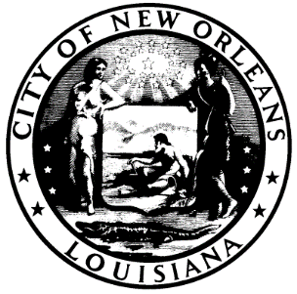

CALL TO ORDER

EARL F. WILLIAMS

CHAIRMAN

ROLL CALL

ANGELA SARKER

ALCOHOLIC BEVERAGE CONTROL BOARD CLERK

PLEDGE OF ALLEGIANCE TO THE FLAG

ADONIS EXPOSÉ

- HEARING NUMBER: 05-22 (A), DISTRICT (A) GIARRUSSO/WILLIAMS

PERMITTEE: LUCKY TAB, LLC

d/b/a THE WILLOW UPTOWN

ADDRESS: 8200 WILLOW STREET, NEW ORLEANS, LA 70118

LICENSE NO.

SUBMITTED: OCTOBER 20, 2022

Allegations:

- Maintaining or Creating a Public Nuisance

New Orleans City Code Section 10-157 (a)(20) provides to wit: Maintaining or creating a nuisance within the meaning of article 667 of the Louisiana Civil Code.

(10) Violation at the premises of any health or sanitation ordinance of the city or the state.

- New Orleans City Code Section Improper and Illegal Conduct 10-157 (a)(4) provides to wit: Permitting any disturbance of the peace or obscene, lewd, sexually indecent, immoral or improper conduct on the licensed premises. Improper conduct, as specified in this subsection, shall consist of actions which violate the penal provisions of this Code or other penal ordinances of the city.

- New Orleans City Code Section 10-157 (a)(12)– provides to wit: Violation at the premises of any of the provisions of section 26-111 et seq., 30-651 et seq., 66-136 et seq., 66-241 et seq., and chapters 82 and 138 or any other health or sanitation ordinance of the city or the state sanitary code.

RECOMMENDATIONS:

- RATIFICATION OF 3-21-23 SALES TAX HEARING

ADJOURNMENT

