THE COUNCIL
City of New Orleans

HELENA MORENO JP MORRELL
Councilmember-At-Large Councilmember -At-Large

JOSEPH I. GIARRUSSO III LESLI D. HARRIS FREDDIE KING III EUGENE J. GREEN, JR. OLIVER M. THOMAS, JR.
Councilmember District A Councilmember District B Councilmember District C Councilmember District D Councilmember District E

AGENDA
Special Meeting of the City Council
to be held in City Council Chamber
on Tuesday, September 12, 2023, at 11:00 A.M. or thereafter

PRESIDENT  JP MORRELL  Councilmember-At-Large | 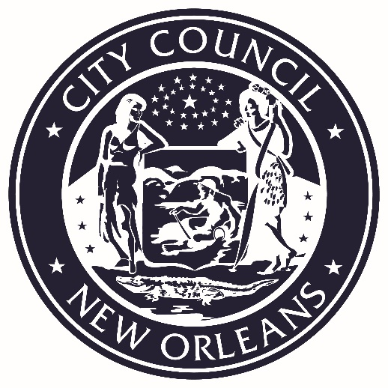 | VICE PRESIDENT  HELENA MORENO  Councilmember-At-Large

PRESIDENT’S CALL
LORA W. JOHNSON
CLERK OF COUNCIL

ROLL CALL
LORA W. JOHNSON
CLERK OF COUNCIL

PUBLIC E-COMMENT FORMS, RULES AND INFORMATION ARE AVAILABLE AT

https://council.nola.gov/home/
REGULAR AGENDA

- PRESENTATION - CITY OF NEW ORLEANS 2022 RECAP

Brief:
Regarding written communication by the Mayor’s Office entitled “City of New Orleans 2022 Recap”.

Annotation:
TO APPEAR.

- MOTION - NO. M-23-424 - BY: COUNCILMEMBER MORRELL

Brief:
A Motion charging Communications Director Gregory Joseph, a member of the unclassified service of the City of New Orleans, with incompetence, neglect of duty, and gross misconduct in reference to his duties and providing otherwise with respect to the removal provisions of Section 3-125 of the Home Rule Charter.

Annotation:
ELECTRONICALLY SUBMITTED.
(Council Rule 34. Postponement Deadline 1/10/24).

- EXECUTIVE SESSION
Brief:
Executive session to discuss the following litigation:
- United States of America v. City of New Orleans, Civil Action No. 12-CV-01924, Section I, Division 2, United States District Court for the Eastern District of Louisiana, Judge Susie Morgan

Annotation:
ELECTRONICALLY SUBMITTED.
TO BE HELD.

- ORDINANCES ON FIRST READING

