ALCOHOLIC BEVERAGE CONTROL BOARD

OF THE CITY OF NEW ORLEANS

AGENDA

ALCOHOLIC BEVERAGE NUISANCE HEARING

TUESDAY, APRIL 30, 2026

1:00 P.M.

THE ALCOHOLIC BEVERAGE CONTROL BOARD

Earl F. Williams, Chairman

Mollie Ponds, Vice-Chair

Adonis Exposé

Nathan Lewis, Jr.

Jonas Nash

Lawrence Galle

Frank Quinn

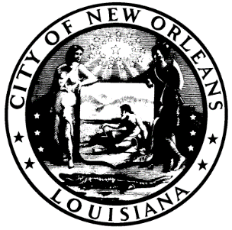

CALL TO ORDER

MOLLIE PONDS

Vice-Chairwoman

ROLL CALL

ANGELA SARKER

ALCOHOLIC BEVERAGE CONTROL BOARD CLERK

PLEDGE OF ALLEGIANCE TO THE FLAG

NATHAN LEWIS

- RATIFICATION OF 4-30-26 SALES TAX HEARING

ADJOURNMENT

