ALCOHOLIC BEVERAGE CONTROL BOARD

OF THE CITY OF NEW ORLEANS

AGENDA

ALCOHOLIC BEVERAGE NUISANCE HEARING

FRIDAY, FEBRUARY 27, 2026

1:00 P.M.

THE ALCOHOLIC BEVERAGE CONTROL BOARD

Earl F. Williams, Chairman

Mollie Ponds, Vice-Chair

Adonis Exposé

Nathan Lewis, Jr.

Jonas Nash

Lawrence Galle

Frank Quinn

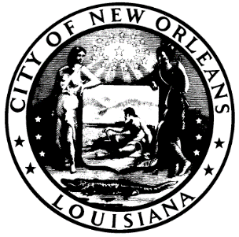

CALL TO ORDER

EARL F. WILLIAMS

CHAIRMAN

ROLL CALL

ANGELA SARKER

ALCOHOLIC BEVERAGE CONTROL BOARD CLERK

PLEDGE OF ALLEGIANCE TO THE FLAG

LAWRENCE GALLE

- RATIFICATION OF 2-27-26 SALES TAX HEARING

ADJOURNMENT

