FRENCH QUARTER ECONOMIC DEVELOPMENT DISTRICT

HELENA MORENO  District Member |  |  | JP MORRELL  District Member
JOSEPH I. GIARRUSSO III  District Member | LESLI D. HARRIS  District Member | FREDDIE KING III  District Member | EUGENE J. GREEN, JR.  District Member | OLIVER M. THOMAS, JR.  District Member

AGENDA
French Quarter Economic Development District
to be held in City Hall, City Council Chamber
on Thursday, June 26, 2025 at 9:55 AM

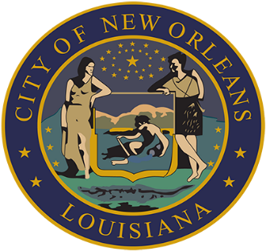

AISHA R. COLLIER
ASSISTANT CLERK OF COUNCIL

FRENCH QUARTER ECONOMIC DEVELOPMENT DISTRICT

- FRENCH QUARTER ECONOMIC DEVELOPMENT DISTRICT (FQ EDD) RESOLUTION NO. R-2025-01
BY: DISTRICT MEMBER KING

Brief:
To give notice pursuant to La. R.S. 42:19.1 of FQ EDD’s intent to adopt a resolution authorizing the calling of an election for November 15, 2025, at which the voters of the FQ EDD will be asked to authorize a five-year renewal of a 0.245% sales tax within the boundaries of the FQ EDD expiring June 30, 2026.

- TO CONSIDER AND TAKE ACTION UPON ANY OTHER MATTERS THAT MAY PROPERLY COME BEFORE THE FQ EDD GOVERNING AUTHORITY.

