FRENCH QUARTER ECONOMIC DEVELOPMENT DISTRICT

HELENA MORENO  District Member |  |  | JP MORRELL  District Member
JOSEPH I. GIARRUSSO III  District Member | LESLI D. HARRIS  District Member | FREDDIE KING III  District Member | EUGENE J. GREEN, JR.  District Member | OLIVER M. THOMAS, JR.  District Member

AGENDA
French Quarter Economic Development District
to be held in City Hall, City Council Chamber
on Thursday, May 25, 2023 at 9:30 AM

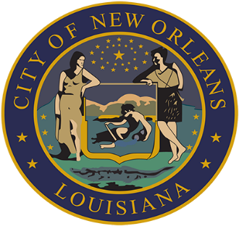

LORA W. JOHNSON
CLERK OF COUNCIL

FRENCH QUARTER ECONOMIC DEVELOPMENT DISTRICT

AGENDA

MAY 25, 2023

- QUARTERLY BUDGET AND EXPENDITURE REPORTS OF THE FQ EDD TRUST FUND - KARLEY FRANKIC, EXECUTIVE DIRECTOR OF FRENCH QUARTER MANAGEMENT DISTRICT

Brief:
A report on the fiscal and operational administration of the French Quarter Economic Development District Trust Fund.

Annotation:
ELECTRONICALLY SUBMITTED.
(Cm. King).
TO APPEAR.

- TO CONSIDER AND TAKE ACTION UPON ANY OTHER MATTERS THAT MAY PROPERLY COME BEFORE THE FQ EDD GOVERNING AUTHORITY.

