ALCOHOLIC BEVERAGE CONTROL BOARD

OF THE CITY OF NEW ORLEANS

AGENDA

ALCOHOLIC BEVERAGE NUISANCE HEARING

MONDAY, JUNE 23, 2025

1:00 P.M.

THE ALCOHOLIC BEVERAGE CONTROL BOARD

Earl F. Williams, Chairman

Mollie Ponds, Vice-Chair

Adonis Exposé

Lawrence Galle, Jr.

Nathan Lewis, Jr.

Jonas Nash

Frank Quinn

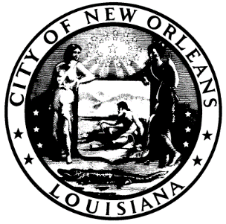

CALL TO ORDER

EARL F. WILLIAMS

CHAIRMAN

ROLL CALL

ANGELA SARKER

ALCOHOLIC BEVERAGE CONTROL BOARD CLERK

PLEDGE OF ALLEGIANCE TO THE FLAG

NATHAN LEWIS

- RATIFICATION OF 6-23-25 SALES TAX HEARING

ADJOURNMENT

