THE COUNCIL
City of New Orleans

HELENA MORENO JP MORRELL
Councilmember-At-Large Councilmember -At-Large

JOSEPH I. GIARRUSSO III LESLI D. HARRIS FREDDIE KING III EUGENE J. GREEN, JR. OLIVER M. THOMAS, JR.
Councilmember District A Councilmember District B Councilmember District C Councilmember District D Councilmember District E

AGENDA
Special Meeting of the City Council
to be held via video conference
on Monday, January 24, 2022 at 9:00 A.M.

PRESIDENT  HELENA MORENO  Councilmember-At-Large | 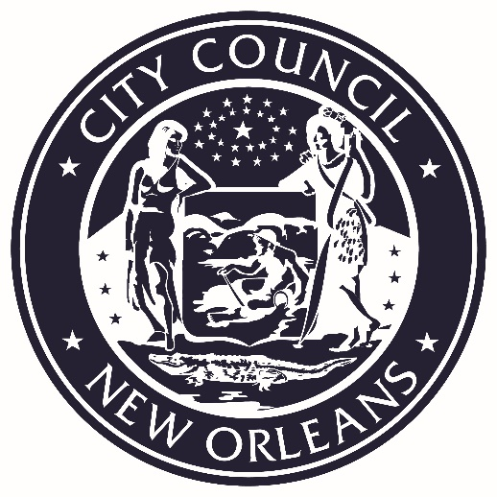 | VICE PRESIDENT  JP MORRELL  Councilmember-At-Large

PRESIDENT’S CALL
LORA W. JOHNSON
CLERK OF COUNCIL

ROLL CALL
LORA W. JOHNSON
CLERK OF COUNCIL

PUBLIC E-COMMENT FORMS, RULES AND INFORMATION FOR THIS VIDEO CONFERENCE MEETING ARE AVAILABLE AT

https://council.nola.gov/home/
PLEASE TURN ALL CELL PHONES AND BEEPERS EITHER OFF OR ON VIBRATE DURING COUNCIL PROCEEDINGS.

REGULAR AGENDA

- Presentation – A WORKING DIALOGUE WITH CRIMINAL JUSTICE
SYSTEM STAKEHOLDERS:

- Voices of Victims of Violence

- New Orleans City Council
Jeff Asher, City Council
Public Safety Analyst

- Orleans Parish District Attorney’s Office
District Attorney Jason Williams

- Criminal District Court
Chief Judge Robin Pittman
Deputy Chief Judge Tracey Flemings-Davillier
Judicial Administrator Rob Kazik

- Orleans Parish Juvenile Court
Chief Judge Ranord J. Darensburg
Judge Candice Bates-Anderson
- Community Representatives
VOTE | Voice of the Experienced
The First 72+

- Administration
Joshua Cox, Senior Advisor & Director of Strategic
Initiatives for Mayor LaToya Cantrell
Commissioner Tenisha Stevens, Office of Criminal Justice Coordination

- The Juvenile Justice Intervention Center
Dr. Kyshun Webster, Executive Director

- Orleans Parish Sheriff Office
Sheriff Marlin Gusman

- Police Association of New Orleans (PANO)
Captain Michael Glasser, President of PANO

Annotation:
TO APPEAR.

- ORDINANCES ON FIRST READING

G:\DoCS\CECIL\COUNCIL\Agenda\2022\01-24-2022 Agenda.docx

