FRENCH QUARTER ECONOMIC DEVELOPMENT DISTRICT

MATTHEW WILLARD  District Member |  |  | JP MORRELL  District Member
AIMEE MCCARRON  District Member | LESLI D. HARRIS  District Member | FREDDIE KING III  District Member | EUGENE J. GREEN, JR.  District Member | JASON  HUGHES  District Member

AGENDA
French Quarter Economic Development District
held in City Hall, City Council Chamber
on Thursday, April 16, 2026 at 12:00 PM

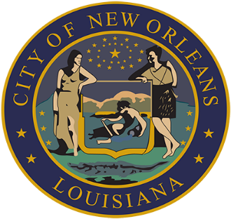

ROLL CALL
AISHA R. COLLIER
CLERK OF COUNCIL

FRENCH QUARTER ECONOMIC DEVELOPMENT DISTRICT

- QUARTERLY BUDGET AND EXPENDITURE REPORTS OF THE FQ EDD TRUST FUND – MICHELLE COURSEAULT, EXECUTIVE DIRECTOR OF FRENCH QUARTER MANAGEMENT DISTRICT; CHRISTINE BONDIO, BOARD CHAIRPERSON OF FRENCH QUARTER MANAGEMENT DISTRICT BOARD OF COMMISSIONERS

Brief:
A report on the fiscal and operational administration of the French Quarter Economic Development District Trust Fund.

Annotation:
TO APPEAR.

- 2026 FQMD BUDGET AMENDMENT PRESENTATION: NEW ORLEANS POLICE DEPARTMENT 8TH DISTRICT DRONE PROGRAM – MICHELLE COURSEAULT, EXECUTIVE DIRECTOR OF FRENCH QUARTER MANAGEMENT DISTRICT; CHRISTINE BONDIO, PRESIDENT OF FRENCH QUARTER MANAGEMENT DISTRICT BOARD OF COMMISSIONERS FQEDD 2026

Brief:
A presentation on the 2026 FQMD budget amendment request to appropriate $250,000.00 for the purpose of implementing the New Orleans Police Department 8th District Drone Program within the FQEDD boundaries.

Annotation:
TO APPEAR.

- FRENCH QUARTER ECONOMIC DEVELOPMENT DISTRICT (FQ EDD) MOTION NO. M-2026-01 - BY: DISTRICT MEMBER KING

Brief:
Consideration of a motion to approve an amendment to the 2026 FQEDD operating budget to appropriate $250,000.00 for the purpose of implementing the New Orleans Police Department 8th District Drone Program within the FQEDD boundaries.

Annotation:
MAY BE RECEIVED.

- TO CONSIDER AND TAKE ACTION UPON ANY OTHER MATTERS THAT MAY PROPERLY COME BEFORE THE FQ EDD GOVERNING AUTHORITY.

\\cno-file01.cityofno.com\City_Council\Clerk_of_Council\DoCS\NAOMI\COUNCIL\FQEDD\4-16-26\APR16FQEDDAGD.docx

