THE COUNCIL
City of New Orleans

HELENA MORENO JP MORRELL
Councilmember-At-Large Councilmember-At-Large

JOSEPH I. GIARRUSSO III LESLI D. HARRIS FREDDIE KING III EUGENE J. GREEN, JR. OLIVER M. THOMAS, JR.
Councilmember District A Councilmember District B Councilmember District C Councilmember District D Councilmember District E

AGENDA
Special Meeting of the City Council
to be held in City Hall Council Chamber
on Tuesday, November 29, 2022, at 11:30 A.M.

PRESIDENT  HELENA MORENO  Councilmember-At-Large | 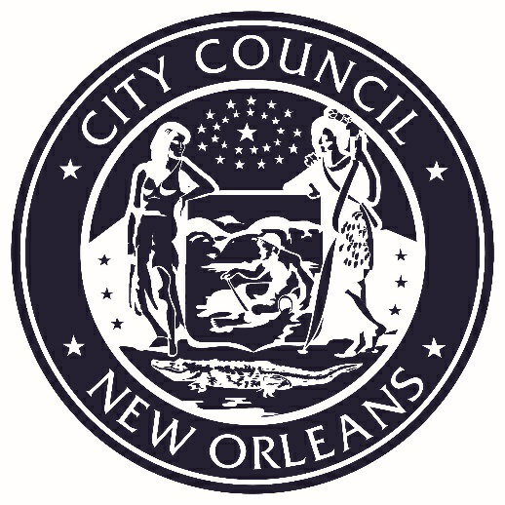 | VICE PRESIDENT  JP MORRELL  Councilmember-At-Large

PRESIDENT’S CALL
LORA W. JOHNSON
CLERK OF COUNCIL

ROLL CALL
LORA W. JOHNSON
CLERK OF COUNCIL

PUBLIC E-COMMENT FORMS, RULES AND INFORMATION ARE AVAILABLE AT
https://council.nola.gov/home/
PLEASE TURN ALL CELL PHONES AND BEEPERS EITHER OFF OR ON VIBRATE DURING COUNCIL PROCEEDINGS.

- COMMUNICATION – FROM SHARON JASPER, SECTION 8 RESIDENT
COUNCIL PRESIDENT

Brief:
Requesting a hearing to appeal of dismissal under the
Revised Statute 40:537.

Annotation:
ELECTRONICALLY SUBMITTED.
(Communication received at the meeting of 11/17/22).

- ORDINANCES ON FIRST READING

G:\Clerk_of_Council\DoCS\CECIL\COUNCIL\Agenda\2022\11-29-2022 Agenda - Special.docx

