FRENCH QUARTER ECONOMIC DEVELOPMENT DISTRICT

HELENA MORENO  District Member |  |  | JP MORRELL  District Member
JOSEPH I. GIARRUSSO III  District Member | LESLI D. HARRIS  District Member | FREDDIE KING III  District Member | EUGENE J. GREEN, JR.  District Member | OLIVER M. THOMAS, JR.  District Member

AGENDA
French Quarter Economic Development District
to be held in City Hall, City Council Chamber
Thursday, November 17, 2022 at 9:30 AM

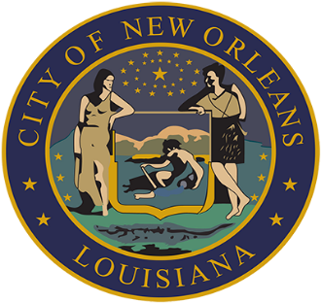

LORA W. JOHNSON
CLERK OF COUNCIL

FRENCH QUARTER ECONOMIC DEVELOPMENT DISTRICT

AGENDA

NOVEMBER 17, 2022

- PRESENTATION OF QUARTERLY BUDGET AND EXPENDITURE REPORTS OF
THE FQEDD TRUST FUND
Brief:
A presentation by Karley D. Frankic, Executive Director of the French Quarter Management District on the fiscal and operational administration of the French Quarter Economic Development District Trust Fund for the Third Quarter of 2022.

Annotation:
TO APPEAR.

- PRESENTATION ON THE 2023 ANNUAL BUDGET OF THE FRENCH QUARTER
ECONOMIC DEVELOPMENT DISTRICT
Brief:
A Presentation by Karley Frankic, Executive Director of French Quarter Management District (FQMD), on the 2023 annual budget, as approved by the FQMD on November 14, 2022.

Annotation:
TO APPEAR.

- FRENCH QUARTER ECONOMIC DEVELOPMENT DISTRICT MOTION NO. M-
2022-??

Brief:
A Motion approving the French Quarter Economic Development District annual
budget for the year 2023.

- TO CONSIDER AND TAKE ACTION UPON ANY OTHER MATTERS THAT MAY
PROPERLY COME BEFORE THE FQEDD GOVERNING AUTHORITY.

- MEETING ADJOURNED

