**ALCOHOLIC BEVERAGE CONTROL BOARD**

**OF THE CITY OF NEW ORLEANS**

**AGENDA**

SALES TAX HEARING

TUESDAY, MARCH 19, 2024

11:30 A.M.

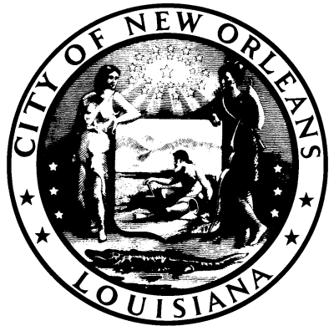

**HEARING OFFICER**

FRANK QUINN

**ALCOHOLIC BEVERAGE CONTROL BOARD CLERK**

ANGELA G. SARKER

1. **HEARING NUMBER: 01-24 (TX), DISTRICT (B) HARRIS/EXPOSÉ**

**PERMITTEE: VYBES INTERNATIONAL GROUP, LLC**

**d/b/a VYBES NATION**

**ADDRESS: 1681 RELIGIOUS STREET, NEW ORLEANS, LA 70130**

**LICENSE NO.**

**SUBMITTED:** **JANUARY 19, 2024**

**Allegations:**

1. **Sales of Alcohol Without License-Delinquent ABO 2023-2024 = Total (8 months)**

**New Orleans City Code Section 10-47.** Permit prerequisite to engaging in business. It shall be unlawful for any person to sell, offer for sale, import, manufacture, distill, rectify or have in possession, for sale, handling, storage or distribution, either at wholesale, retail or otherwise, any alcoholic beverage or to engage in the business of dealer without first having obtained from the department of safety and permits a permit to engage in such business or a temporary number as provided in section 10-108.

**RECOMMENDATIONS:**

1. **HEARING NUMBER: 03-24 (TX), DISTRICT (C) KING/QUINN**

**PERMITTEE: BOURBON STREET, INC.**

**d/b/a MANGO MANGO**

**ADDRESS: 400 BOURBON STREET, NEW ORLEANS, LA 70130**

**LICENSE NO.**

**SUBMITTED: FEBRUARY 19, 2024**

**Allegations:**

1. **Sales of Alcohol Without License-Delinquent ABO 2023-2024 = Total (9 months)**

**New Orleans City Code Section 10-47.** Permit prerequisite to engaging in business. It shall be unlawful for any person to sell, offer for sale, import, manufacture, distill, rectify or have in possession, for sale, handling, storage or distribution, either at wholesale, retail or otherwise, any alcoholic beverage or to engage in the business of dealer without first having obtained from the department of safety and permits a permit to engage in such business or a temporary number as provided in section 10-108.

**RECOMMENDATIONS:**

1. **ADJOURNMENT**