ALCOHOLIC BEVERAGE CONTROL BOARD

OF THE CITY OF NEW ORLEANS

AGENDA

ALCOHOLIC BEVERAGE NUISANCE HEARING

TUESDAY, APRIL 16, 2024

1:00 P.M.

THE ALCOHOLIC BEVERAGE CONTROL BOARD

Earl F. Williams, Chairman

Lisa Manning, Vice-Chair

Adonis Exposé

Nathan Lewis, Jr.

Jonas Nash

Mollie Ponds

Frank Quinn

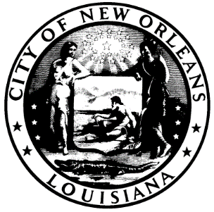

CALL TO ORDER

EARL F. WILLIAMS

CHAIRMAN

ROLL CALL

ANGELA SARKER

ALCOHOLIC BEVERAGE CONTROL BOARD CLERK

PLEDGE OF ALLEGIANCE TO THE FLAG

LISA MANNING

- RATIFICATION OF 4-16-24 SALES TAX HEARING

- ADJOURNMENT

