THE COUNCIL
City of New Orleans

HELENA MORENO JP MORRELL
Councilmember-At-Large Councilmember-At-Large

JOSEPH I. GIARRUSSO III LESLI D. HARRIS FREDDIE KING III EUGENE J. GREEN, JR. OLIVER M. THOMAS, JR.
Councilmember District A Councilmember District B Councilmember District C Councilmember District D Councilmember District E

AGENDA
Regular Meeting of the City Council
to be held in City Hall Council Chamber
on Monday, December 30, 2024 at 10:00 A.M.
PRESIDENT  HELENA MORENO  Councilmember-At-Large | 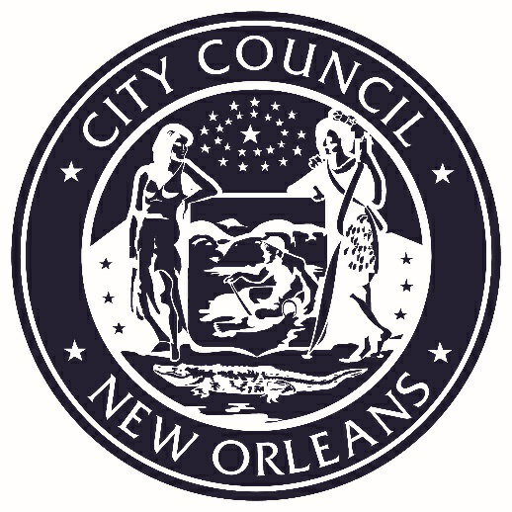 | VICE PRESIDENT  JP MORRELL  Councilmember-At-Large

ROLL CALL
AISHA R. COLLIER
ASSISTANT CLERK OF COUNCIL

INVOCATION
JAMES C. SIMMONS

PLEDGE OF ALLEGIANCE
LESLI D. HARRIS
COUNCILMEMBER DISTRICT “B”

PUBLIC E-COMMENT FORMS, RULES AND INFORMATION ARE AVAILABLE AT
https://council.nola.gov/home/

PLEASE SILENCE DEVICES DURING COUNCIL PROCEEDINGS.

REGULAR AGENDA

PUBLIC COMMENT RULES
All public comment shall comply with the following Council Rules:
- Each commenter must personally submit a comment card to the Clerk.
- All commenters must state their names and addresses and whether they are being paid to appear.
- One comment per speaker, per item.
- Each comment must be entirely germane to the agenda item.
- Comments may not exceed two minutes.
- Ceding of time is not permitted.
- Each item is limited to 30 minutes of public comment.
- Public comment on land use items shall not commence before 11 a.m.

DEFERRAL RULES
Any annotation of a request to defer an agenda item is purely tentative until confirmed during the meeting. A request to defer an agenda item may be withdrawn or overruled pursuant to Council Rules.

POSTPONEMENT RULES
Unless subject to an earlier deadline or deferred to a specific date, legislative instruments will be postponed indefinitely and removed from future agendas if not acted upon within 120 days of first reading or appearance on a Council agenda.

- LEGISLATIVE GROUPING

- CONSIDERATION OF CITY PLANNING COMMISSION MASTER PLAN RECOMMENDATIONS

Brief:
Consideration of the recommendations for the Master Plan Future Land Use Map amendments.

Annotation:
(Report received 11/21/24). (Cn. deadline 1/5/25).

- CAL. NO. 34,938 – BY: COUNCILMEMBER KING

Brief:
An Ordinance to amend and reordain Ordinance No. 24,079 M.C.S., providing for the adoption of the Master Plan (also known as the "Plan for the 21st Century: New Orleans 2030"), to adopt changes to the future land use map as recommended by the City Planning Commission in its reports transmitted August 22, 2024, as reconsidered as directed by the Council on September 19, 2024 in M-24-540 and as recommended on reconsideration by the City Planning Commission on November 21, 2024; and otherwise to provide with respect thereto.

Annotation:
(This matter was introduced 12/5/24).

- CAL. NO. 34,966 – BY COUNCILMEMBERS GIARRUSSO, MORENO AND THOMAS
(BY REQUEST)

Brief:
An Ordinance to authorize the Mayor of the City of New Orleans to enter into an Agreement between the City of New Orleans (“City”) and the Sewerage and Water Board of New Orleans (“Board”), to transfer and consolidate drainage operations within the City of New Orleans. Pursuant to Acts 763 and 103 of the 2024 Legislative Session. The City will transfer from the Department of Public Works all employees and equipment used for drainage maintenance to the Sewerage and Water Board of New Orleans. The transfer of all drainage operations in the City of New Orleans shall be implemented by January 1, 2025, as more fully detailed in the Agreement form as Exhibit “A”; and otherwise to provide with respect thereto.

Annotation:
(This matter was introduced 12/19/24).

- ORDINANCES ON FIRST READING

g:\clerk_of_council\docs\mills\council\agendas\2024\dec 30 agd.docx

