RIVERWALK-SPANISH PLAZA ECONOMIC
DEVELOPMENT DISTRICT

HELENA MORENO  District Member |  |  | JP MORRELL  District Member
JOSEPH I. GIARRUSSO III  District Member | LESLI D. HARRIS  District Member | FREDDIE KING III  District Member | EUGENE J. GREEN, JR.  District Member | OLIVER M. THOMAS, JR.  District Member

AGENDA
Riverwalk-Spanish Plaza Economic Development District
to be held in City Hall, City Council Chamber
on Thursday, October 10, 2024 at 9:30 AM

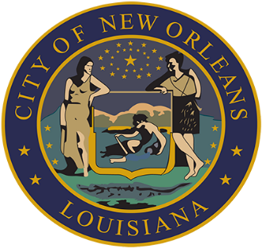

ROLL CALL
AISHA R. COLLIER
ASSISTANT CLERK OF COUNCIL

- Resolution No. R-2023-4D – bY: DISTRICT MEMBER KING (BY REQUEST)

Brief:
A RESOLUTION amending prior resolutions to commence the levy of a sales tax within the Riverwalk-Spanish Plaza Economic Development District and providing for other matters in connection with the foregoing.

- Resolution No. R-2023-5A – BY: DISTRICT MEMBER KING (BY REQUEST)

Brief:
A RESOLUTION repealing a resolution approving the Riverwalk-Spanish Plaza Economic Development District to enter into a Cooperative Endeavor Agreement with the City of New Orleans and Rockstep Riverwalk, LLC, and providing for other matters in connection therewith.

- Resolution No. R-2023-6A – BY: DISTRICT MEMBER KING (BY REQUEST)

Brief:
A RESOLUTION repealing a general bond resolution authorizing and providing for the issuance from time to time of Revenue Bonds, in one or more series, of the Riverwalk-Spanish Plaza Economic Development District, and providing for other matters with respect to the foregoing.

- Resolution No. R-2024-1 – by: district member king (by request)

Brief:
A RESOLUTION approving the Riverwalk-Spanish Plaza Economic Development District to enter into a Cooperative Endeavor Agreement with the City of New Orleans and Rockstep Riverwalk, LLC, and providing for other matters in connection therewith.

- TO CONSIDER AND TAKE ACTION UPON ANY OTHER MATTERS THAT
MAY PROPERLY COME BEFORE THE RSP EDD GOVERNING AUTHORITY.

- MEETING ADJOURNED

g:\clerk_of_council\docs\naomi\council\riverwalk -spanish plaza edd\oct10agd.docx

