ALCOHOLIC BEVERAGE CONTROL BOARD

OF THE CITY OF NEW ORLEANS

AGENDA

ALCOHOLIC BEVERAGE NUISANCE HEARING

WEDNESDAY, SEPTEMBER 10, 2025

1:00 P.M.

THE ALCOHOLIC BEVERAGE CONTROL BOARD

Earl F. Williams, Chairman

Lisa Manning, Vice-Chair

Adonis Exposé

Nathan Lewis, Jr.

Jonas Nash

Mollie Ponds

Frank Quinn

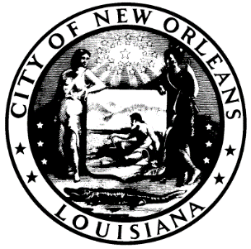

CALL TO ORDER

EARL F. WILLIAMS

CHAIRMAN

ROLL CALL

ANGELA SARKER

ALCOHOLIC BEVERAGE CONTROL BOARD CLERK

PLEDGE OF ALLEGIANCE TO THE FLAG

JONAS NASH

- HEARING NUMBER: 057-25 (TX), DISTRICT (C) KING/ QUINN

PERMITTEE: THALI LLAMA, LLC

d/b/a PLUME ALGIERS

ADDRESS: 1113 TECHE STREET, NEW ORLEANS, LA 70114

LICENSE NO.

SUBMITTED: JUNE 30, 2025

Allegations:

- Sales of Alcohol Without License-Delinquent ABO 2023-2024 (12 months) + 2024-2025 (12 months) = 24 months

New Orleans City Code Section 10-47. Permit prerequisite to engaging in business. It shall be unlawful for any person to sell, offer for sale, import, manufacture, distill, rectify or have in possession, for sale, handling, storage or distribution, either at wholesale, retail or otherwise, any alcoholic beverage or to engage in the business of dealer without first having obtained from the department of safety and permits a permit to engage in such business or a temporary number as provided in section 10-108.

RECOMMENDATIONS:

- RATIFICATION OF 8-15-25 SALES TAX HEARING

- RATIFICATION OF 9-10-25 SALES TAX HEARING

ADJOURNMENT

