FRENCH QUARTER ECONOMIC DEVELOPMENT DISTRICT

HELENA MORENO  District Member |  |  | JP MORRELL  District Member
JOSEPH I. GIARRUSSO III  District Member | LESLI D. HARRIS  District Member | FREDDIE KING III  District Member | EUGENE J. GREEN, JR.  District Member | OLIVER M. THOMAS, JR.  District Member

AGENDA
French Quarter Economic Development District
to be held in City Hall, City Council Chamber
on Thursday, November 7, 2024 at 9:40 AM

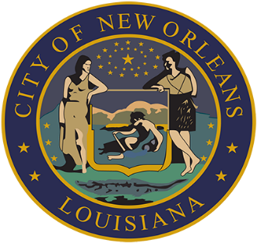

AISHA R. COLLIER
ASSISTANT CLERK OF COUNCIL

FRENCH QUARTER ECONOMIC DEVELOPMENT DISTRICT

AGENDA

NOVEMBER 7, 2024

- QUARTERLY BUDGET AND EXPENDITURE REPORTS OF THE FQ EDD TRUST FUND – MICHELLE COURSEAULT, EXECUTIVE DIRECTOR OF FRENCH QUARTER MANAGEMENT DISTRICT; JANE COOPER, BOARD CHAIRPERSON OF FRENCH QUARTER MANAGEMENT DISTRICT BOARD OF COMMISSIONERS

Brief:
A report on the fiscal and operational administration of the French Quarter Economic Development District Trust Fund.

Annotation:
(Cm. King).
TO APPEAR.

- 2025 FQMD BUDGET PRESENTATION – MICHELLE COURSEAULT, EXECUTIVE DIRECTOR OF FRENCH QUARTER MANAGEMENT DISTRICT; JANE COOPER, PRESIDENT OF FRENCH QUARTER MANAGEMENT DISTRICT BOARD OF COMMISSIONERS

- TO CONSIDER AND TAKE ACTION UPON ANY OTHER MATTERS THAT MAY PROPERLY COME BEFORE THE FQ EDD GOVERNING AUTHORITY.

