ALCOHOLIC BEVERAGE CONTROL BOARD

OF THE CITY OF NEW ORLEANS

AGENDA

ALCOHOLIC BEVERAGE NUISANCE HEARING

WEDNESDAY, JULY 29, 2026

1:00 P.M.

THE ALCOHOLIC BEVERAGE CONTROL BOARD

Earl F. Williams, Chairman

Mollie Ponds, Vice-Chair

Adonis Exposé

Nathan Lewis, Jr.

Craig Mitchell

Nissan Patel

LaTanja Silvester

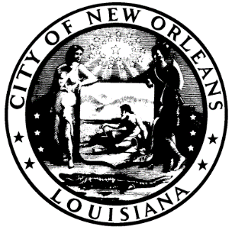

CALL TO ORDER

MOLLIE PONDS

Vice-Chairwoman

ROLL CALL

ANGELA SARKER

ALCOHOLIC BEVERAGE CONTROL BOARD CLERK

PLEDGE OF ALLEGIANCE TO THE FLAG

NATHAN LEWIS

- COMMUNICATION – ABO APEAL FROM ANH PHAN, OWNER OF NEWTON CORNER MART, 1600 NEWTON STREET

Brief:

Requesting assistance with renewal of ABO license by waving the requirement of the property tax to renew ABO license for property located at 1600 Newton Street.

RECOMMENDATION:

- RATIFICATION OF 7-29-26 SALES TAX HEARING

ADJOURNMENT

